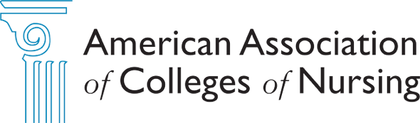

October 2026

To: Deans of AACN Member Schools

From: AACN Nominating Committee
Subject: Call for Nominations for 2027 Election

The following is the Call for Nominations for the Special Election to fill the unexpired term for Member-at-Large on the AACN Board of Directors through March 2028. Your leadership in advancing excellence in academic nursing is more important than ever, and we encourage you to submit an application to run for this open position.

The benefits of serving are many and include:
- A high level and significant role in advancing excellence in academic nursing.
- Engagement in discussions about strategic goals and priorities, higher education and healthcare issues, and challenges facing the nursing profession.
- A unique opportunity to serve the profession while maximizing the value of your AACN membership.

Term of Office: December 2026-March 2028

Eligibility for Elected Office: Candidates must be the Chief Academic Nurse Administrator (Dean) of an AACN member institution.

The following criteria will be used when making selections for the slate:
- Need for representatives reflecting member balance
- Need for representation across institutional types/sizes and geographical regions
- Special consideration will be given to candidates with previous service on national boards and committees, distinguished awards and special recognitions, research/scholarship, and/or thought leadership
- Conflict of interest (see FAQs)
- Candidates must commit to serving the full term of the position
Board Competency Matrix: The Board Competency Matrix will be used by the Nominating Committee to inform the final slate of candidates. Please see the attached information with additional explanation about the Board Competency Matrix.

Frequently Asked Questions (FAQs): The attached FAQs were developed to answer general questions and time commitment.
Nomination Packet Due Date: Wednesday, November 11, 2026

Submission Process: The complete nomination packet consists of the following documents:
Signed Consent to Serve Statement Biographical Data Form
Personal Statement

The completed nomination materials should be submitted online or sent via e-mail as a Word document to AACNnominations@aacnnursing.org.

For questions and additional information, please contact AACN staff or the Nominating Committee Chair by emailing AACNNominations@aacnnursing.org.

Important Note: Campaign activities are limited to the presentation of qualifications as provided to AACN through the biographical data form and personal statement. Any additional campaigning by candidates or their supporters is strongly discouraged.


Call for Nominations Frequently Asked Questions

Am I eligible to serve on the Board of Directors?
Academic Board candidates must be the Chief Academic Nurse Administrator (Dean) of an AACN member institution. Practice Board candidates must be a CNO or hold a similar executive-level nursing practice position. Practice Board candidates are advanced from a member dean and cannot be directly affiliated with the academic institution of currently serving Board member.

Do I need to have previous volunteer service with AACN to serve on the Board of Directors or Nominating Committee?
The committee looks for previous experience and considers both service through AACN and with other organizations. For the Executive Committee positions - Chair-Elect, Secretary and Treasurer – more recent service on the AACN Board is noted. Experience and deep engagement with AACN is strongly considered for positions on the Nominating Committee.

What is the time commitment to serve on the Board of Directors and Nominating Committee?
The Board of Directors meets 4 times annually with interim conference calls as needed. The Board also has an orientation and welcome luncheon during the March meeting. Board members are expected to attend all scheduled Board meetings. Board members spend an average of two hours per week on Board service; the Board Chair and Board Chair-Elect spend considerably more time (up to 6-8 hours weekly). The Nominating Committee meets twice annually in person and has 5-6 conference calls, which take place primarily in summer/early fall when preparing the slate of candidates.

How long are the terms and what are the term limits?
Board member terms are 2 years, and candidates may serve two terms. Term limits across all positions on the Board of Directors is 8 years. The Nominating Committee term is 2 years.
How does the Nominating Committee select the slate of candidates?
The Nominating Committee spends considerable time reviewing the submitted materials from each candidate. Criteria such as membership diversity, the need for representation of institutional types/sizes and geographic regions, as well as conflict of interest are considered. In addition, the Committee considers previous experience on national Boards and Committees, distinguished awards/special recognitions, research/scholarship, and thought leadership. Information based on the Board Competency Matrix will complement these criteria.

How will the Board Competency Matrix inform the work of the Nominating Committee?
The Board Competency Matrix will inform the work of the Nominating Committee based on current and future needs for expertise needed to advance strategic priorities of the association.

How is Conflict of Interest (COI) considered?
In looking at potential conflicts of interest, AACN considers service on other national nursing Boards and Board governance committees, such as Finance, Audit, Nominating, and Fundraising. Board members of national nursing organizations and their accrediting organizations are not eligible for election to the AACN Board of Directors. Members in AACN-elected leadership positions abide by the duties of care, loyalty, and obedience. The duty of loyalty means that Board and committee members hold AACN as their primary loyalty. Specific questions about COI may be further addressed by contacting the Chair of the Nominating Committee or AACN Chief Operating Officer.

How can I learn more about AACN’s opportunities for volunteer service?
Information about AACN’s volunteer opportunities is available on the website and shared via communications and at meetings. Members seeking volunteer opportunities should complete the volunteer interest form on their MyAACN dashboard.

Board Competency Matrix
The Board Competency Matrix was approved by the Board of Directors in October 2019 and is used to inform the work of the Nominating Committee about the needed expertise and experience for Board service. This matrix will complement the current working grid used by the committee that focuses on candidate background, leadership/service, institution type/size, and geographic location.

The overall foundational statement for the competency matrix is as follows:
The Board of Directors is committed to providing the leadership needed for AACN to fulfill its mission as the catalyst for excellence and innovation in nursing education, research, and practice.

This statement reflects the Board’s commitment to AACN’s vision and mission in providing leadership for AACN.
The matrix identifies competencies that all Board members must have. These are captured under the following categories:
- Moral Courage and Innovation – Includes leadership, strategic thinking, and change management.
- Access for All – Extends to backgrounds, expertise, thinking, and experiences.
- Culture of Inquiry – Includes listening, mutual respect, constructive debate, and considering multiple perspectives.
- Ethics and Integrity – Includes personal accountability, transparency, and Duty of Care, Loyalty, and Obedience.
- Continuous Learning – Includes striving for excellence, continuous improvement, and revitalization.
The competencies for the Board as a whole were developed for the matrix. Collectively the Board must bring this expertise for optimal success, but not everyone must be expert in each area.
- Health and Healthcare – Includes healthcare leadership and strategy; health access; social determinants of health; workforce; quality and patient safety; research; and health policy.
- Higher Education – Includes academic leadership; teaching and learning; higher education strategy; health profession education; scholarship; and access, connection, and engagement.
- Innovation and Technology – Includes education technologies; practice technologies; big data and analytics; and innovation management.
- Governance and Finance - Includes business expertise; managing risk and compliance; fundraising and philanthropy; financial expertise; and governance.

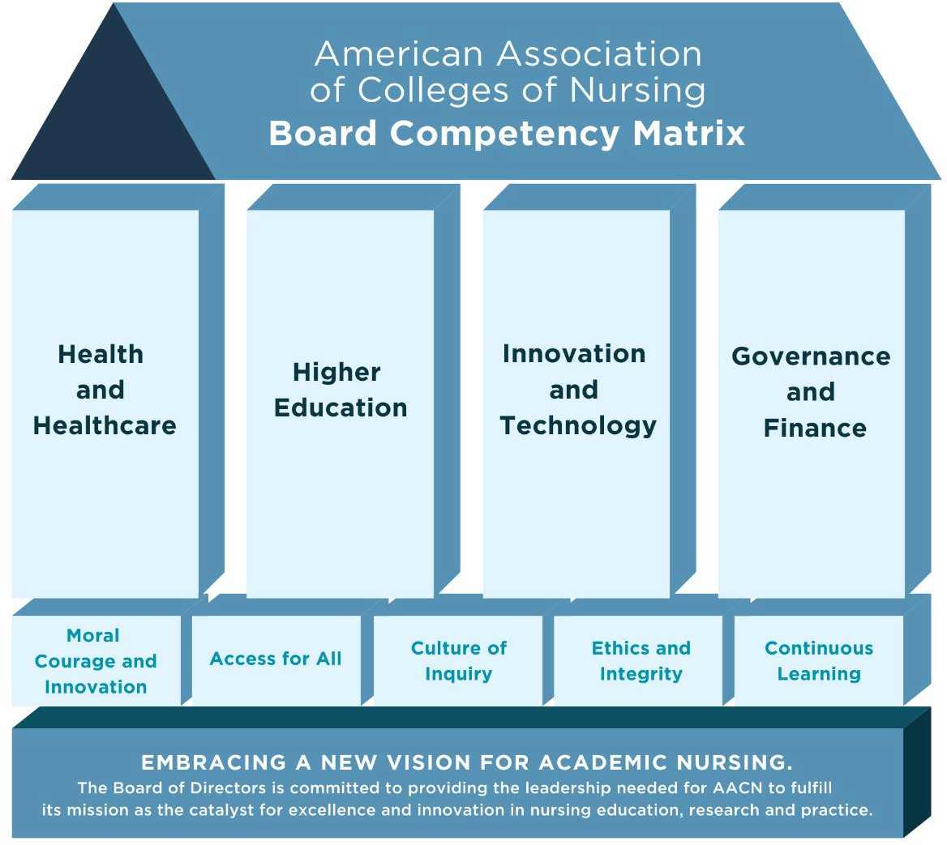

Foundational Statement
The Board of Directors is committed to providing the leadership needed for AACN to fulfill its mission as the catalyst for excellence and innovation in nursing education, research, and practice.

Competencies for All Board Members
- Moral Courage and Innovation – Includes leadership, strategic thinking and change management.
- Access for All – Extends to backgrounds, expertise, thinking and experiences.
- Culture of Inquiry – Includes listening, mutual respect, constructive debate, and considering multiple perspectives.
- Ethics and Integrity – Includes personal accountability, transparency, and Duty of Care, Loyalty and Obedience.
- Continuous Learning – Includes striving for excellence, continuous improvement and revitalization.

Competencies for Board as a Whole
- Health and Healthcare – Includes healthcare leadership and strategy; access for all; social determinants of health; workforce; quality and patient safety; research and health policy.
- Higher Education – Includes academic leadership; teaching and learning; higher education strategy, health profession education; scholarship; and diversity, access and inclusion.
- Innovation and Technology – Includes education technologies; practice technologies; big data and analytics; and innovation management.
- Governance and Finance - Includes business expertise; risk and compliance, fundraising and philanthropy; financial expertise; and governance.
October 2019, updated March 2026

AACN NOMINATION PACKET
The complete nomination packet consists of the following items:

Consent to Serve and Conflict of Interest Statement – This form is to be completed by the nominee stating his/her consent to serve if chosen for the position. Board members agree to participate in all Board meetings and the dates are included on the form.
Nomination Biographical Data Form - The Biographical Data Form will be distributed to the membership in the electronic mail ballot should you be chosen as a candidate. Space allotted to each category may be modified. Candidates also are requested to submit their full curriculum vitae.

Personal Statement - The Candidate Personal Statement will be distributed to the AACN membership in the electronic mail ballot. Please limit the personal statement to 2 pages.

Nomination Packet Due Date: November 11, 2026

AMERICAN ASSOCIATION OF COLLEGES OF NURSING CONSENT TO SERVE AND CONFLICT OF INTEREST STATEMENT
The Consent to Serve is to be completed by the nominee stating his/her consent to serve if chosen for the position. Please note that Board members are expected to attend four Board meetings each year. The dates for these meetings are highlighted below.

NAME/ OFFICE FOR WHICH NOMINATED
I understand that if elected as a Board of Directors member, I am expected to attend all Board meetings annually. These meetings take place during the AACN Deans Annual Meeting and Academic Nursing Leadership Conference, prior to the Doctoral Education Conference and each Summer.

The Board meeting dates for 2026 – March 2028 are:
- January 10-11, 2027, Coronado, CA in advance of Doctoral Education Conference
- March 13-14, 2027, Washington, DC in advance of Deans Annual Meeting
- March 16, 2027 – New Board Member Orientation at close of Deans Annual Meeting
- July 21-23, 2027 – Location TBD - Thought Leaders, Board Development and Board Meeting
- October 23-24, 2027, in advance of the Academic Nursing Leadership Conference
- January 9-10, 2028, Naples, FL in advance of Doctoral Education Conference
- March 18-19, 2028, Washington, DC in advance of Deans Annual Meeting
AACN will reimburse expenses for travel and two days hotel and per diem for the Board meetings that take place during Doctoral Conference and Summer meeting. For the Board meetings that take place during the Academic Nursing Leadership Conference and AACN Deans Annual Meeting, AACN will reimburse expenses for two nights hotel and per diem. There is also the potential that special Board meetings could be necessary for the purpose of a Board retreat or strategic planning. Travel and per diem would be provided for these meetings.

Legal Duties of Board Members
I hereby agree that if I am elected to hold a position with the American Association of Colleges of Nursing on the Board of Directors, I will conduct myself in a manner consistent with the Legal Duties of Board Members, which includes the following:
The Duty of Care requires that Board members remain fully informed about the organization’s activities, participate in decisions, and do so in good faith. Board members must use the care and judgment of an ordinarily prudent person in similar circumstances. The Duty of Care is carried out by attendance at Board meetings, advance preparation for meetings, and use of independent and best judgment.

The Duty of Loyalty requires Board members to exercise their power in the interest of the organization and not in their own interest or the interest of another entity, particularly one in which they have a formal relationship. When acting on behalf of the organization, Board members must put the interest of the organization before their personal and professional interest. The Board member is only permitted to act in the interest of AACN. Board members need to disclose if they are being offered gifts or gratuities from people or organizations doing business with AACN. The Duty of Loyalty requires Board members to give undivided allegiance to the organization when making decisions affecting the organization. The Duty of Loyalty is carried out by disclosure of any conflict of interest, adherence to the organization’s conflict of interest policy, and avoidance of the use of organizational information or opportunities for the individual’s personal gain or benefit.
The Duty of Obedience requires Board members to comply with all applicable federal, state, and local laws, adhere to the organization’s bylaws, and remain the guardians of the mission. Although Board members may exercise their own reasonable judgment concerning how the organization should best meet its mission, they are not permitted to act or speak publicly in a way that is inconsistent with the central goals of the organization. The Duty of Obedience is carried out by thorough examination of the organization’s compliance with regulatory and reporting requirements, and other documents governing the organization and its operations (such as bylaws and policies), involvement in ensuring that Board decisions are within the scope of the organization’s mission, and speaking “with one voice” after a decision has been made, even if the individual Board member voted against it.

Conflict of Interest
I hereby agree that if I am elected to hold a position with the American Association of Colleges of Nursing on the Board of Directors or Nominating Committee, I will avoid all conflicts of interest whether perceived or actual. I agree to disclose to the AACN Board of Directors any positions of leadership that I hold in any nursing or other related organizations. I further agree to disclose to the Board of Directors of the AACN any specific matters where I believe I may have a conflict of interest and I further agree not to influence any matters where such a conflict exists.
Areas of Conflict of Interest requiring disclosure include the following:

Are you a member of any board, staff, or committee of another organization that potentially has competing products, services, policies, and/or missions?
Yes No If yes, list below:
Have you material or other self-interest which is in opposition to the interests of AACN?
Yes No If yes, please list:
Are you privy to information as an AACN Board/committee member, which would be of use to an outside individual or organization in which the individual has an interest?
Yes No

If yes, please list:

Are you in a role requiring efforts that may compete with the work of AACN?
Yes No If yes, please list:
Are you in a personal relationship with a Board, committee, or staff member that creates a conflict on a particular issue?
Yes No If yes, please list:
Signature
Please sign indicating your Consent to Serve, agreement to avoid all Conflicts of Interest, and agreement to attend all Board of Directors Meetings.

Signature Date

AMERICAN ASSOCIATION OF COLLEGES OF NURSING NOMINATION BIOGRAPHICAL DATA FORM
The Biographical Data Form is limited to 1-2 pages. The Biographical Data Form will be distributed to the membership in the electronic mail ballot should you be chosen as a candidate. Space allotted to each category may be modified.
Name, Title, Credentials:
Institution Address:

Positions Held (List last 2 positions and years of service):

Previous Service (include board, committee or task force service (AACN and other), any other organizational service and years served):

Areas of Expertise/Recognition (credentials, teaching/research scholarship, thought leadership, professional achievements, national recognition, distinguished awards, etc.):

NOMINATION PERSONAL STATEMENT
The Candidate Personal Statement will be distributed to the AACN membership in the electronic mail ballot. Please limit the personal statement to 2 pages.

Name/Institution:

Please state why you are interested in serving in the position you are running for.

What do you feel your major contributions would be to the organization?

How do you envision meeting the mission and goals of the association?

Briefly describe a situation where you promoted one or more of AACN’s values.

The Board Competency Matrix identifies competencies that are needed from all Board members and the competencies needed for the Board as a whole. Please review the four areas of health and healthcare, higher education, innovation and technology, and governance and finance, and identify/prioritize your strengths in these areas.

