Assignment & Grading Rubric
For this assignment, you will complete a self-assessment and a reflection journal entry that evaluates personal well-being and outlines an action plan.

Part 1: Complete an assessment of your lifestyle habits by answering the lifestyle vital questions below and calculating your A-SMART vital signs total score (Downes & Tryon, 2025, pp. 17-18).

Lifestyle Vital Sign | Screening Questions | Score
Adopt healthy eating | - How many days per week do you eat ≥5 fruits and vegetables?  Scores responses: 6-7 days (0 points), 4-5 days (1 point), 2-3 days (2 points), 0-1 day (3 points).  - How many days per week do you consume sugary foods/drinks?  Scores responses: 0-1 day (0 points), 2-3 days (1 point), 4-5 days (2 points), 6-7 days (3 points).  Sum scores for questions 1 & 2. A score of ≥3 indicates a need for further screening, counseling, or referral.
Stress less | - In the past month, how often have you felt your stress level was not manageable?  Scores responses: Never (0 points), Almost never (1 point), Sometimes (2 points), Fairly often (3 points), Very often (4 points)  - Do you feel that you have personal support?  Scores responses: Yes (0 points), No (1 point)  Sum scores for questions 3 & 4. A score of ≥3 indicates a need for further screening, counseling, or referral
Move more | - On average, how many days a week do you engage in moderate to vigorous physical activity, such as walking?  - On average, how many minutes do you engage in physical activity at this level?  Multiply responses for questions 6 & 7 for total minutes per week. Score responses: ≥150 minutes of moderate activity or 75 minutes of vigorous activity (0 points), <150 minutes of moderate activity or 75 minutes of vigorous activity (1 point). A score of 1 indicates a need for further screening, counseling, or referral.
Avoid alcohol | - On any single occasion during the past 3 months, have you had more than 5 drinks containing alcohol?  Scores responses: No (0 points), Yes (1 point)  A score of 1 indicates a need for further screening, counseling, or referral.
Rest move | - How many hours do you sleep on a typical night?  Scores responses: 7-9 hours (0 points), <7 hours or >9 hours (1 point)  A score of 1 indicates a need for further screening, counseling, or referral.
Treat tobacco use | - Do you currently vape or use any form of tobacco?  Scores responses: No (0 points), Yes (1 point)  A score of 1 indicates a need for further screening, counseling, or referral.
TOTAL SCORE | Sum scores from each category.  Total scores of ≥10 points indicate an overall unhealthy lifestyle vital signs score. With one or more areas needing further screening, counseling, or referral.

Next, complete an assessment utilizing the wellness wheel found at: https://thewheelofwellness.wordpress.com/wellness-wheel/

“Like any wheel, you want it to be round and smooth. Like a car with a flat tire, life won’t run very smooth if your wheel is skewed. This might give you some indications on where you can focus energy on trying to obtain more peace and happiness” (The Wheel of Wellness, n.d., para. 2).

Using the diagram below, color in each segment to where you rate your level of satisfaction out of 10. A level of 10 indicates you are fully satisfied.

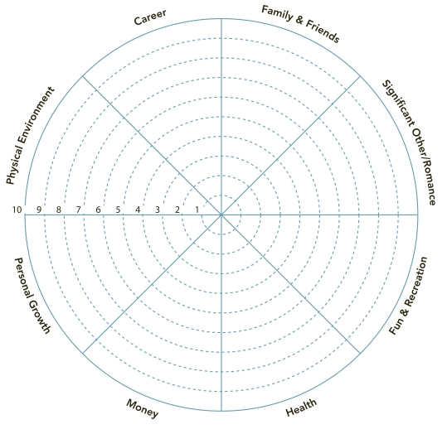

Part 2: Answer the following reflection journal prompts and outline an action plan.
Journal Prompts:
- What is your A-SMART vital signs total score (do not include the breakdown for each section of the score)? Reflect on the total score. How does this make you feel and why?
- What are the A-SMART self-care practices in your life that are not being addressed?
- What are the potential barriers to completing your A-SMART self-care practices?
- Share a copy of your wellness wheel that includes the rating for each category. The wheel can be embedded within the body of the paper (no larger than 1/4 of a page in size) or included as an appendix. Reflect on the scores of each individual category and the shape of your wheel.
- What aspects of your wellness are you most satisfied with? What are your strengths?
- What areas of your wellness need improvement?

Action Plan: Pick 3 areas for improvement identified from your two self-assessments (A-SMART and Wellness Wheel). Develop a SMART goal (Specific, Measurable, Attainable, Relevant, and Time based) for each area of improvement (3 goals total) incorporating an evidence-based strategy. At least one strategy should include current or emerging technology (apps for mindfulness, fitness tracking, telehealth consultations, etc.). List out your SMART goals and reflect on what will motivate you to achieve these goals. You will actually work towards these SMART goals throughout the semester and complete a self-reflection on your progress at the conclusion of the course.

If you need a refresher on SMART Goals, check out this helpful video: How to write SMART goals and objectives video

Assignment Guidelines:
- Write your assignment in an Microsoft Word document following APA (7th edition) guidelines.
- Use Times New Roman font, 12-point font size.
- Include a title page and reference list.
- Include a brief introduction that outlines the importance of personal well-being and states the purpose of your paper, and a conclusion that summarizes your key insights and implications for your future self-care practices.
- Double-space the paper from start to finish. The paper is anticipated to be 4-6 pages in length. Do not exceed 8 pages of text.
- Use brief headings to organize your paper to ensure you have covered each question of the assignment. We recommend your paper outline follows the order of the question prompts.
- Be specific in your answers.
- You will be graded on grammar, punctuation, and editorial style as well as the quality and content of your paper.
- Upload your completed assignment to the LMS by the assigned due date/time. Reach out to course faculty with any questions.

Grading Rubric:

Criteria | Points Possible | Points Earned | Comments
Question 1-6 Reflection Responses: Each question is answered completely and clearly, addressing all components of the prompt. Responses demonstrate depth of analysis, connection to course concepts, and use of specific examples or evidence from self-assessments. | 12 (2 pts each)
Action Plan is outlined and:  - Includes 3 identified areas for self-improvement, each with a SMART goal.  - Each goal integrates an evidence-based strategy, with at least 1 including current or emerging technology.  - Provides a reflection on personal motivation to achieve these goals. | 9
Paper includes a focused introduction and conclusion. Ideas flow logically with clear headings aligned to prompts. | 2
Writing is professional and scholarly, free from grammar and spelling errors, and utilizes proper APA format throughout (title page, citations, references, spacing, font). | 2
Total | 25

References

Downes, L. & Tryon, L. (2025). Health promotion and disease prevention for advanced practice: Integrating evidence-based lifestyle concepts. Jones & Bartlett Learning. ISBN-13: 9781284249200
The Wheel of Wellness. (n.d.). Wellness wheel. https://thewheelofwellness.wordpress.com/wellness-wheel/

