**Policy Change Fishbone and Force Field Analysis**

Group 7 - Alyssa Lunday, Courtney Cser, Miranda Greci, Riane Pope, Sophie Reisner

Texas State University St. David’s School of Nursing

NURS 4351: Leadership and Management in Nursing

Drs. Kim Belcik and Stacey Cropley

March 27, 2021

**Policy Change Fishbone and Force Field Analysis**

The issue we have identified within the Bartlett community is a lack of primary care, public health, and preventative services within the community boundaries. At present, the closest available health care resources are located approximately 30 minutes away from the community due to the lack of industry within the rural town. The community of Bartlett is an underserved, impoverished community that is in need of better access to health care. Thus, we are proposing support of a policy that would enable current Medicaid beneficiaries to receive expanded paramedic services in the community including primary and preventative services.

**Figure 1**

*Fishbone of Policy Change: Paramedicine*

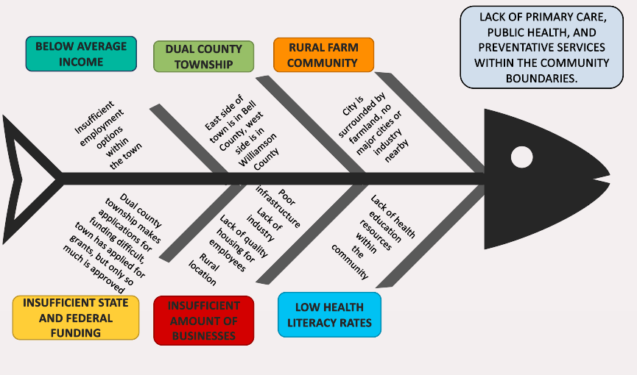

The fishbone diagram above depicts a breakdown of our group’s perception of one of the main community issues in Bartlett, TX which is lack of local primary care and preventative services to community members. Major factors contributing to this problem have to do with the town’s location 20 miles from the nearest cities with available health resources. The impoverished status of the community combined with insufficient industry within the town makes it difficult for community members to pay for services, and for the town to receive adequate state and federal funding to implement changes and improve healthcare options.

One of the biggest legislative issues for the community is the fact that it lies between two counties. Dual county township status means that the mayor and other city officials have to go through twice as many channels to implement policy changes for the entirety of the community. Low health literacy rates among community members contributes to a higher number of preventable health issues such as uncontrolled hypertension and diabetes. Overall, the rural town of Bartlett, TX needs more primary and preventative healthcare service support within the community to be able to positively make an impact on the health of its members.

**Figure 2**

*Force Field Analysis of Policy Change: Paramedicine*

**Issue:** Lack of readily accessible primary and preventative healthcare services for the community of Bartlett, TX

**Identified Change:** Improved Medicaid beneficiary services through paramedicine outlined in Senate Bill No. 2028

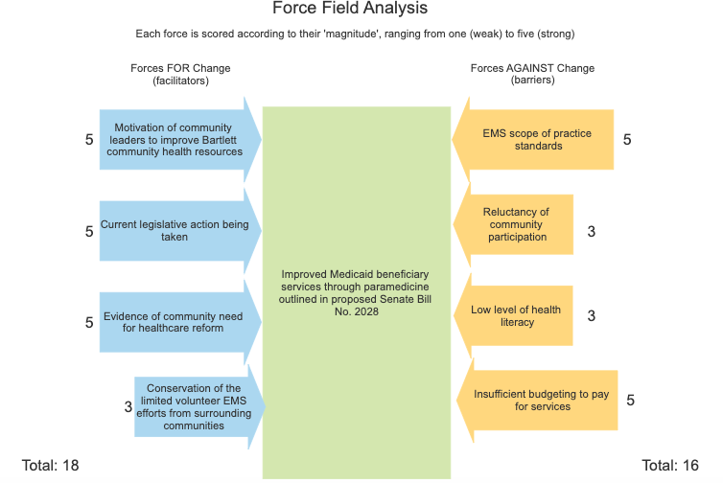

Overall, there are barriers to the proposed policy change, but competing facilitators with potential for action are evident. The strongest facilitators for policy change include the activity in current legislative sessions to approve S.B. 2028, motivation of community leaders to improve Bartlett’s available and accessible health resources and the evidence of community need for healthcare reform found within the community itself. The strongest barriers to policy change include current EMS scope of practice standards and the insufficient funding for new healthcare services in Bartlett. An identified facilitator for policy change is the conservation of limited volunteer EMS efforts from surrounding communities, while two other identified barriers to policy change include the reluctance of community participation and the low level of health literacy seen among community residents.

**Conclusion**

In conclusion, Bartlett is an underserved community in need of improved access to healthcare. This is due to the fact that they are a dual county township, which makes applications for funding difficult. Additionally, they are a rural community surrounded by farmland and far from health resources within the nearest major cities. These factors, in combination with insufficient employment options within the town leading to low income, and lack of health education resources, contribute to social factors that lead to a decrease in their access to healthcare. Our recommended policy change is aimed at increasing the availability of paramedics and paramedic services to Medicaid beneficiaries within the town so that more trained medical professionals are able to go out to the community and provide adequate primary and preventative healthcare services. Current legislative efforts including the support of Senate Bill No.2028 will hopefully facilitate this change that will contribute to the health promotion of Bartlett community members.

**References**

*Fishbone diagram for powerpoint and google slides*. (2021). PresentationGo. _____Retrieved March 27, 2021, from _____https://www.presentationgo.com/presentation/fishbone-diagram-powerpoint- google-slides/

*Force field analysis*. (n.d.). Minnesota Department of Health. Retrieved March 27, _____2021, from _____https://www.health.state.mn.us/communities/practice/resources/phqitoolbox/forceield.html

S.B.2028, 87th Legislature. (2021). <https://capitol.texas.gov/tlodocs/87R/billtext/pdf/SB02028I.pdf#navpanes=0>