Healthy North Texas Website for Community Analysis

Overview

General Features

The Healthy North Texas Community Health Website is an initiative of the DFWHC Foundation through the work of the Community Health Collaborative. This process is a community-based effort to improve the health and well-being of North Texas residents.

Healthy North Texas is an initiative of the DFWHC and a collaborative effort among hospitals (see Figure 1 for current donors), community organizations, universities, business organizations, health and social service providers and community members. The community improvement process includes data collection, identification of areas for improvement, priority-setting, collaborative efforts to address the priority needs in North Texas and monitoring the success of the improvement efforts.

Figure 1:
Partners who Donate to HNT Maintenance and Development Activities


Data Source

The data comes from a variety of state and national sources, including the National Cancer Institute, the Centers for Disease Control, the American Community Survey and many state-specific sources. Most of the data is reported on an annual basis. Each indicator page includes the source of the data, the URL of the source, and when this data was last updated.

Conduent Healthy Communities Institute (HCI) provides demographic and secondary data on health, health determinants, and quality of life topics. Data is typically presented in comparison to the distribution of counties, state average, national average, or target values. Data is primarily derived from state and national public health sources. Through the Conduent HCI indicator platform, community members have easy access to critical information about their community.

In terms of the overall approach, the primary aims of the Conduent HCI indicator platform are to inform and facilitate positive change. To inform, we must provide accurate, reliable, and timely data at a geographically meaningful level. We accomplish this by selecting sources that meet the following criteria:
- A validated methodology for data collection and analysis
- Scheduled, regular publication of findings
- Focus on data values for small geographic areas, such as counties and postal codes that are available for all county-level locations in the U.S or locally through our community partners

Geographic Areas
Geographically speaking, the data is available by region [north Texas] and by the associated geographic areas. Those areas might be used to pinpoint a specific geographic location. The location-based choices by which we can focus the analysis are:
- Region [North Texas]
- County
- Census Place (City)
- Metropolitan Statistical Area (MSA) e.g., Dallas-Plano-Irving or Fort Worth-Arlington]
- Substrate Region [e.g., 3a or 3b]
- Texas Education Agency (TEA) Region [10, 11, or 12]
- Zip Code
- Census Track

Indicators
Indicators are used to measure outcomes of a population health and the community characteristic for health promotion. Major subgroups for categorizing indicators are:
- Health
- Community
- Economy
- Education
- Environmental Health [such as Air Quality]

Features and Functions
The main features and functions available on the HNT website are Community Health Collaborative, Explore Data, See How We Compare, Locate Resources and Funding, and Learn More. (See Figure 2 for specific layout.) For this learning activity, “Explore Data” will be used. We will use the “Dashboard Landing Page” to create a community-based dashboard.

Figure 2:
Layout for Main Menu Features and Functions


Create Report and Comparison

Diabetes Indicator(s) for Adults
Diabetes is a leading cause of death in the United States. According to the Centers for Disease Control and Prevention (CDC), more than 25 million people have diabetes, including both diagnosed and undiagnosed cases. This disease can have a harmful effect on most of the organ systems in the human body; it is a frequent cause of end-stage renal disease, non-traumatic lower-extremity amputation, and a leading cause of blindness among working age adults. See Appendix A for a list of how indicators are measured to determine healthcare outcomes.
Persons with diabetes are also at increased risk for ischemic heart disease, neuropathy, and stroke. According to the CDC, the direct medical expenditures attributable to diabetes are over $116 billion. Diabetes disproportionately affects minority populations and the elderly, and its incidence is likely to increase as minority populations grow and the U.S. population ages. Note that for the HNT website, “Adults with Diabetes” indicator information is available by “Census Place (City). See Figure 3.

Figure 3
Locations Available for Diabetes Analysis
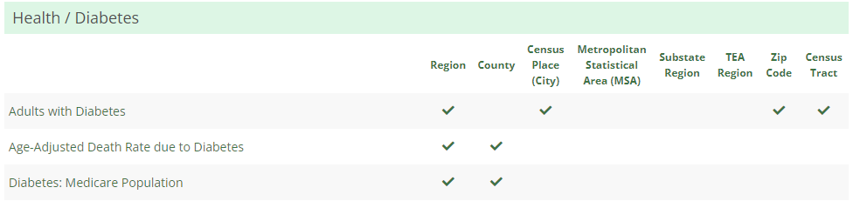

Diabetes Indicators for City of Arlington
On the main menu of HNT, select “Explore Data > Dashboard Landing Page”
On the “Explore Data” web page, select ‘Community Dashboard”
On the “Find and Indicator” dropdown list, select Health/Diabetes for Adults with Diabetes (see Figure 4).

Figure 4
Selecting Indicator Web Page
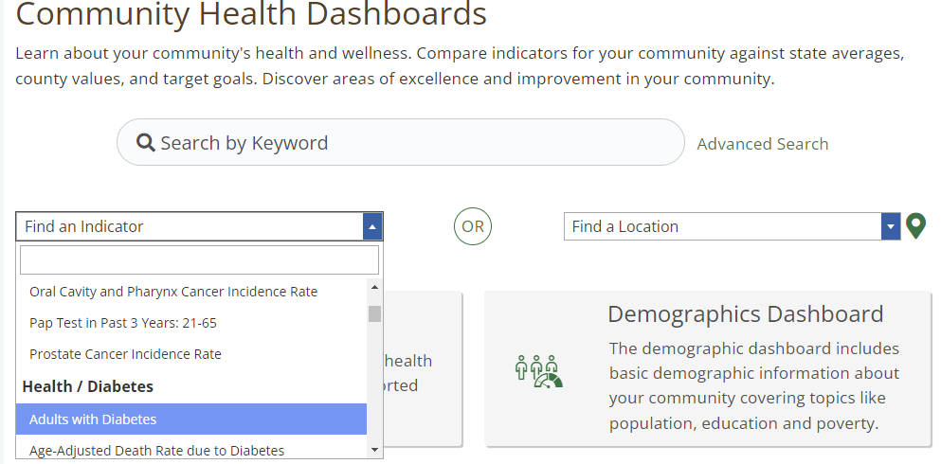

Once the Indicator is selected, the location can be determined.

On the next web page, click the “Select a Location” dropdown list option and then click on “Census Place (City): Arlington (see Figure 5).

Figure 5
Selecting Location Web Page
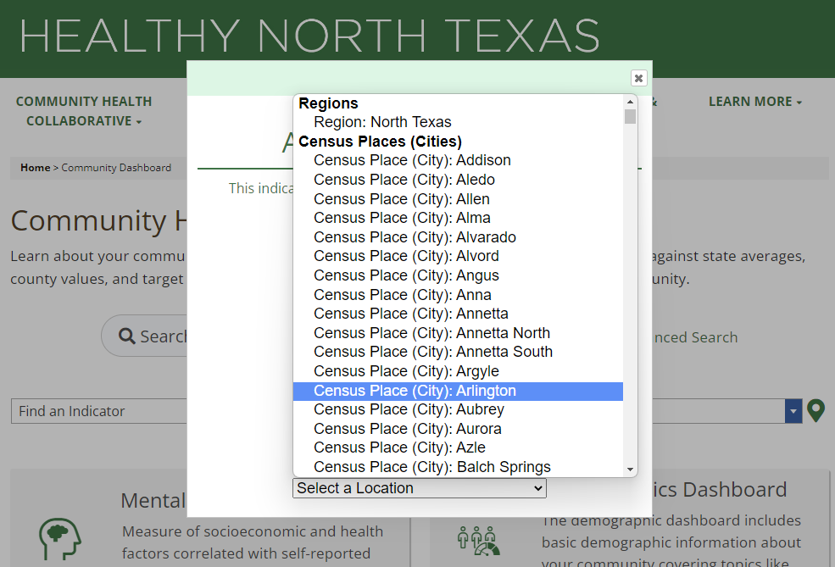

The HNT report for adults with diabetes in Arlington for 2019 will display as indicated in Figure 6.

Figure 6a
Report for Adults with Diabetes in Arlington, Texas in 2019: Overview
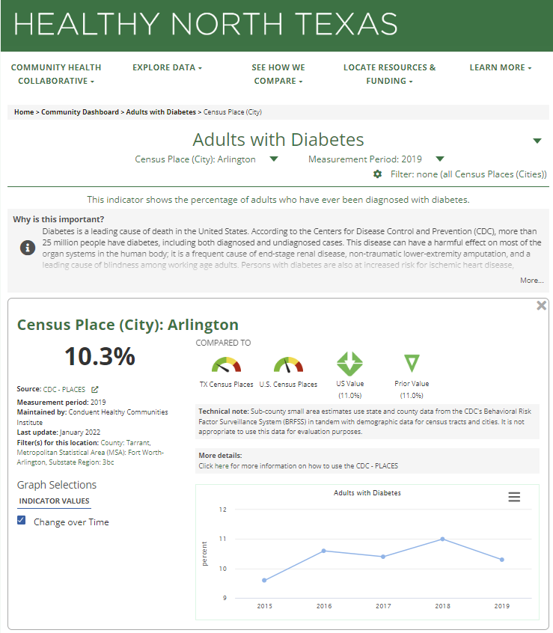

Figure 6b
Report for Adults with Diabetes in Arlington, Texas in 2019: Detailed View

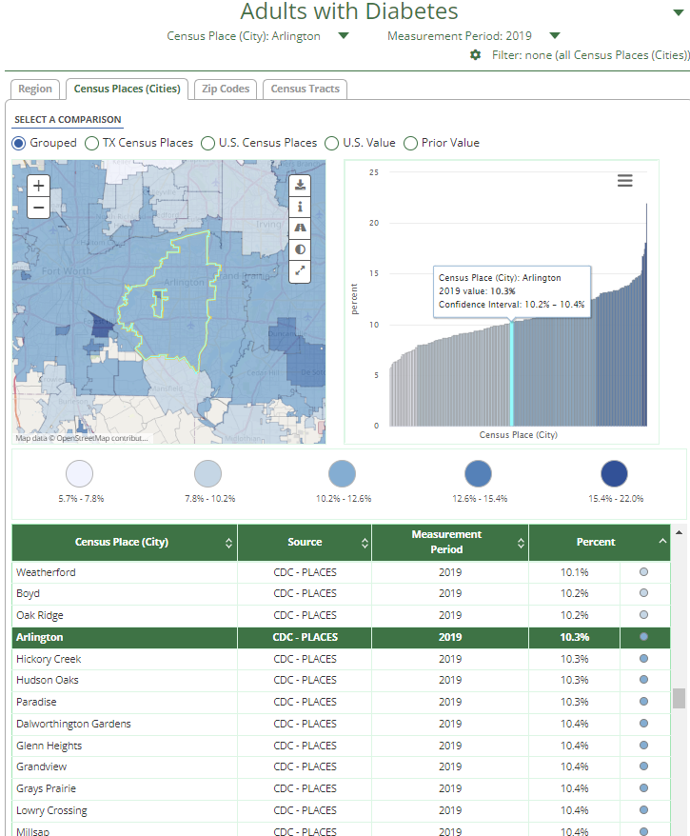

Comparison: Diabetes Indicators for Low and High rates of diabetes conditions

Appendix A: Indicator Measures

Prevalence: The total number of cases of a disease within a population at a given point in time. Prevalence is often given as a rate (the number of total cases divided by the number of individuals at risk for the disease). Prevalence measures how much of a disease is in the population and can be thought of as a snapshot of a disease's progression in the population.

Incidence: The number of new cases of a disease within a population. Incidence is often given as a rate (the number of new cases divided by the number of individuals at risk for the disease). Incidence measures the rate of occurrence of a disease in the population.

Rate: A measure or ratio of one quantity against another. Rates are often used when describing the presence of disease within a population.

Ratio: An explanation of the relationship between two amounts that shows the number of times one value contains or is contained within the other.

Age-Adjusted: Age adjustment, also called age standardization, is a technique used to allow populations to be compared when the age profiles of the populations are quite different. For indicators, the default rate type is age-adjusted (as opposed to crude), when age-adjusted rates are provided by the source. Crude rates are used when age-adjusted rates are not available from the source.

Confidence Interval: The confidence interval describes how well a survey represents the population it refers to. Consider a survey that measured the obesity rate as 35% with a 95% confidence level and a margin of error of 5%. In this scenario, 95 out of 100 times the survey is conducted, the measured percentage of the population that is obese falls between 30% and 40% (the confidence interval).

Margin of Error: The margin of error is another term used to describe how well a survey represents the population it refers to. In the above example, the margin of error is 5%.

Median: The value at the midpoint of a distribution of values ordered from smallest to largest.

Distribution: A distribution is created by taking all zip code, county, or state values, ordering them from smallest to largest, and dividing them into quartiles based on their order.

Unstable: A value that is marked unstable indicates a rate where small changes in the input will result in large changes in the rate. This is often due to small counts in the numerator or denominator (the input) used to calculate a rate. Unstable rates should be interpreted with caution because it is difficult to differentiate between random and true changes in the rates.

Jenks’ Natural Breaks: A way to classify data values into optimal groups, often used in epidemiological mapping. The natural breaks method reduces the variance within groups of values and maximizes variance between groups of values.

