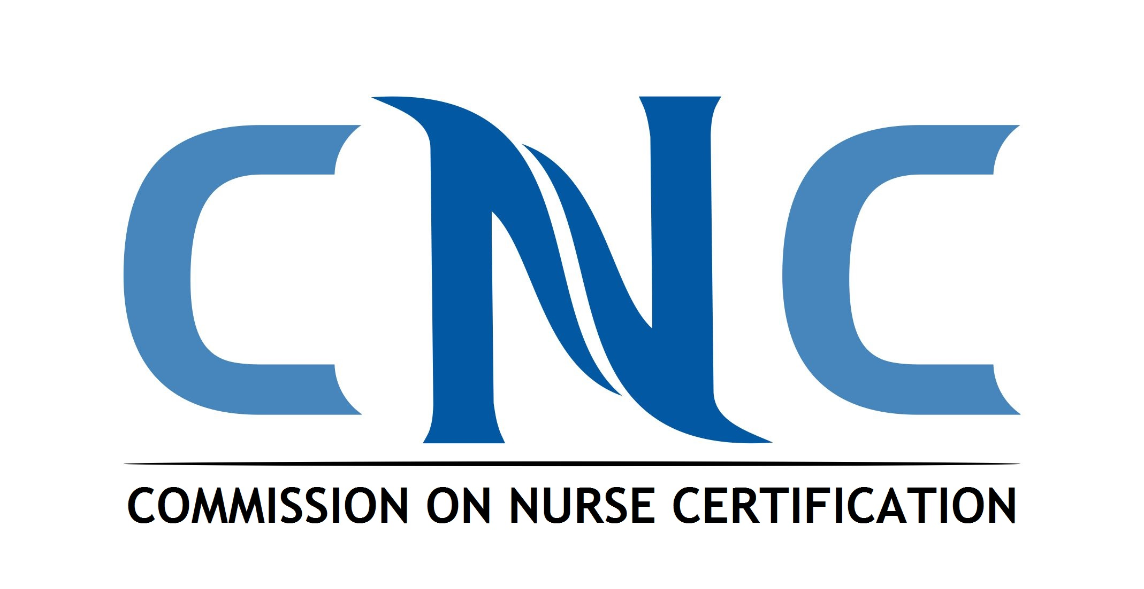

MARKETING COMMITTEE
APPLICATION FORM

Complete the form below. Submit the application along with a career summary, current vitae/resume, and consent statement form by March 15, 2024 to CNC Staff at cnl@aacnnursing.org.

1. I am applying to serve on the CNC Marketing Committee:

Name:

Credentials:

Title:

Institution/Organization:

Address:

City: State: Zip:

Phone: Fax:

E-mail:

2. You may contact the following individual as my professional reference:

Name:

Credentials:

Title:

Institution/Organization:

Address:

City: State: Zip:

Phone: Fax:

E-mail:

3. As a CNL, I represent the following setting (please check):

Academia

Practice

4. Attach a summary of your career experience and qualifications (limit 500 words). Include:

- Reason for applying.
- Total number of years as a registered nurse and/or total number of years in current profession.
- CNL knowledge/experience.

5. Attach a current vitae/resume.

6. Complete and submit the Consent Statement Form.

Commission on Nurse Certification
Marketing Committee
Consent Statement

I have voluntarily applied to serve on the Commission on Nurse Certification’s Marketing Committee. If appointed, I acknowledge the responsibilities of service during my term as follows:

- Strive to achieve the goals and mission of the CNC.
- Adhere to the CNC bylaws, policies, and procedures.
- Serve my term of two years.
- Maintain confidentiality including but not limited to all CNC discussions, actions, and data reports.
- Avoid all conflicts of interest – perceived or actual.
- Disclose any perceived conflicts of interest and not influence matters where such a conflict may exist.
- Maintain ethical behavior and practices.
- Attend and participate in CNC committee meetings. (Consecutive absenteeism may result in dismissal of service.)
- Be prepared for all committee meetings; review supporting material/information for committee agenda items and seek clarification when necessary.
- Adhere to all deadlines and complete assignments as applicable.

I understand that all CNC contacts with news media are initiated only by the Communications and Media Relations Department of the American Association of Colleges of Nursing (AACN). If I wish to issue news releases or other announcements to media regarding CNC, such announcements will be reviewed by AACN’s Communications and Media Relations Department prior to distribution. The Chair of the CNC Board of Commissioners will respond to all media inquiries in consultation with AACN’s Chief Communications Officer and CNC Director.

Your signature on this document confirms understanding and acceptance of these conditions. I have read, understand, and agree to comply with the above conditions.

Name:

Title:

Company:

Address:

City: State: Zip:

Email: Phone:

I Accept (By selecting the “I Accept” button, you are signing this form electronically. You agree your electronic signature is the legal equivalent of your manual signature on this form.)

Date:

